**bespire**

**ISO Registry of Geodetic Codes and Parameters**

User Guide

25 November 2014

Copyright © 2014 Statens kartverk.

This software was developed by bespire UG (haftungsbeschränkt) under a contract with the Norwegian Mapping Authority (Statens kartverk).

This software uses components that were developed by Frankfurt University of Applied Sciences under a contract with the German Federal Agency for Cartography and Geodesy (Bundesamt für Kartographie und Geodäsie).

No part of this publication may be reproduced, stored in a retrieval system, or transmitted, in any form, or by any means, electronic, mechanical, photocopying, recording or otherwise, without the prior consent of the copyright owner.

Author of this document: Florian Esser

**Contents**

1 Introduction 1

1.1 What is the ISO Registry of Geodetic Codes and Parameters? 1

2 Getting started 2

2.1 The Registry website 2

2.2 Browsing Registry content 2

2.3 List of registered items 2

2.4 Item details 4

2.5 Providing feedback 5

2.6 Sign up for the registry 6

2.7 Manage your account 8

3 The registry in detail 10

3.1 Registers 10

3.2 Item classes 10

3.3 Roles 10

4 Submitting proposals 12

4.1 Prerequisites 12

4.2 Submitting new content 13

4.3 Clarifying an item 15

4.4 Superseding an item 15

4.5 Retiring an item 16

5 Managing proposals 17

5.1 Tasks as a submitter 17

5.1.1 Discussing a proposal 17

5.1.2 Withdrawing a proposal 19

5.1.3 Submitting saved proposals 19

5.1.4 Appealing the control body decision 19

5.2 Tasks as a register manager 20

5.3 Tasks as a control body member 21

5.4 Discussing a proposal 21

5.5 Deciding a proposal 22

6 Managing your organization 23

6.1 Tasks as an organization’s Point of Contact 23

6.2 Delegating rights to organization user 24

6.3 Managing role requests 25

7 Bibliography 26

8 List of figures 26

9 List of tables 27

# Introduction

This document is a manual for users of the ISO Registry of Geodetic Codes and Parameters.

## What is the ISO Registry of Geodetic Codes and Parameters?

The ISO Registry of Geodetic Codes and Parameters is a structured database of coordinate reference systems and transformations that is accessible through an on-line registry system.

This registry is provided under the auspices of ISO Technical Committee 211 on geographic information/geomatics and conforms to ISO standards ISO 19111:2007 (Spatial referencing by coordinates), ISO/TS 19127:2005 (Geodetic codes and parameters), ISO 19135:2005 (Procedures for item registration) and its soon to be published revision ISO 19135-1 (Procedures for item registration - Part 1: Fundamentals), and ISO 19135-2:2012 (Procedures for item registration -- Part 2: XML schema implementation).

Users of the registry may query and view data and generate reports via anonymous guest access. Registered users may also submit proposals for new additions or clarifications to the registry.

# Getting started

## The Registry website

The user interface of the online registry system displays an application menu containing links to all registry sections accessible to the user, including a list of registers and their respective contained item classes.

## Browsing Registry content

To browse the content of the Geodetic Codes & Parameters register, click on the register’s name in the application menu, right below the *Register* folder. If you’d like to display only register items of a certain type, click on item class groups (e. g. *Coordinate Reference Systems*) or an individual item class (e. g. *Geodetic CRS*). If you cannot see the item class you want to view, make sure you have opened the corresponding item class group by clicking on the  symbol positioned on the left of the item class group.

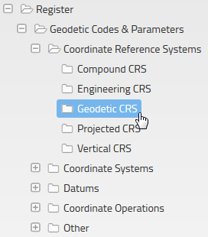

Fig. 1 – Item classes within an item class group

## List of registered items

When you click on an item class group or individual item class, you will be presented with a list of items of that class or classes registered in the Geodetic Codes & Parameters register.

To sort the list, click on the column header (e. g. *Name*). To filter the list of items, enter your search keyword in the Search input box situated on the top right side of the list.

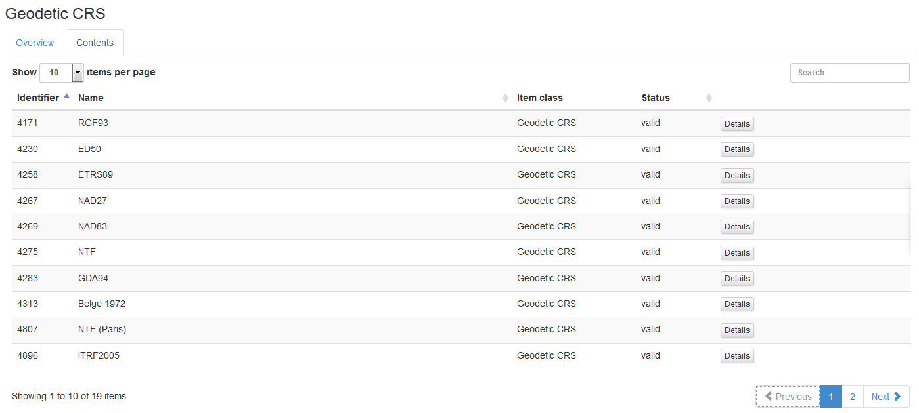

Fig. 2 - List of registered items

## Item details

To inspect the details of a registered item, open the list of registered items as described in the previous section and click on the Details button next to item you wish to view. You may wish to sort or filter the item list in order to find the desired item. After clicking on the Details button, you will be redirected to a detailed description of the register item.

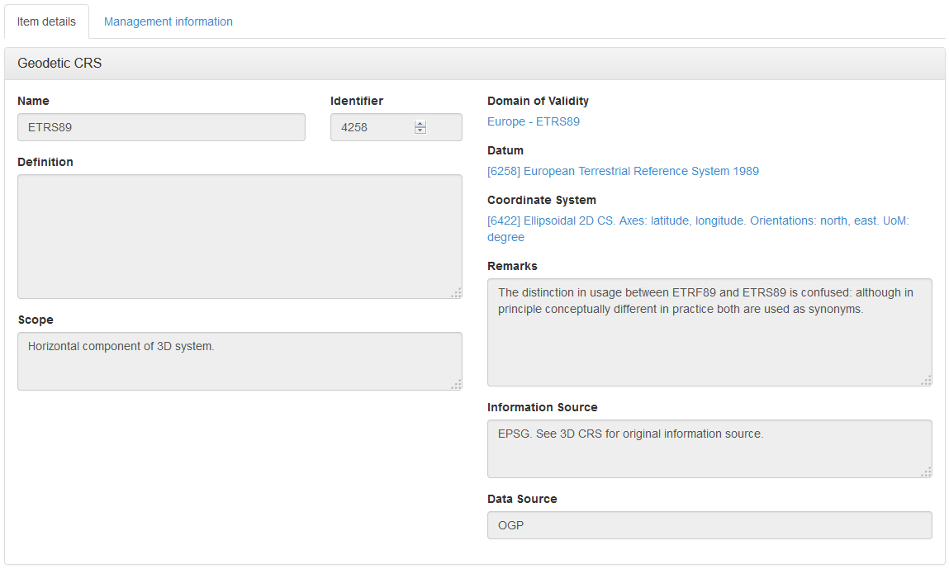

Fig. 3 - Details of a registered item

The details view of a register item may contain textual attributes, lists as well as references to other registered items. References to other registered items are displayed as blue links. You can use these links to navigate directly to the details view of the referenced item.

**Management information**

To access additional management information of a registered item, click on the *Management information* tab on the item details page. The management information tab contains information about the following events:

* Addition of the item to the register (green header)
* Clarifications of item details (blue header)
* Supersession of the item (yellow header)
* Retirement of the item (red header)
* Proposed or denied changes of any kind (grey header)

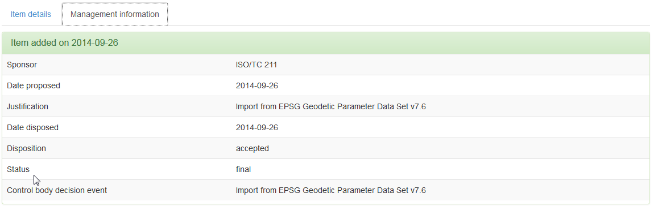

Fig. 4 - Management information of a register item

For each event the following properties will be displayed:

|  |  |
| --- | --- |
| Property | Description |
| Sponsor | The organization that proposed the change. |
| Date proposed | The date the sponsor organization proposed the change. |
| Justification | The justification for the change provided by the sponsor organization. |
| Date disposed | The date the control body of the Geodetic Codes & Parameters register decided on the proposal. |
| Disposition | The control body’s decision (*accepted* or *rejected*) or *withdrawn* if the proposal was withdrawn by the sponsor organizations before a decision was made by the control body. |
| Status | The status of the proposal (*pending*, *final*, *tentative*). |
| Control body decision event | The event or meeting where the proposal decision was made by the control body. |

Tab. 1 - Proposal management information

## Providing feedback

If you experience a problem while using the ISO Registry of Geodetic Codes and Parameters or have a suggestion how to improve the user experience, you may provide feedback by clicking on the blue *Provide feedback* button that is displayed on the right edge of all pages.

After clicking the *Provide feedback* button you will be presented with a dialog where you may submit technical errors or suggestions for improvement. In addition to a textual summary and description you may also attach a screenshot.

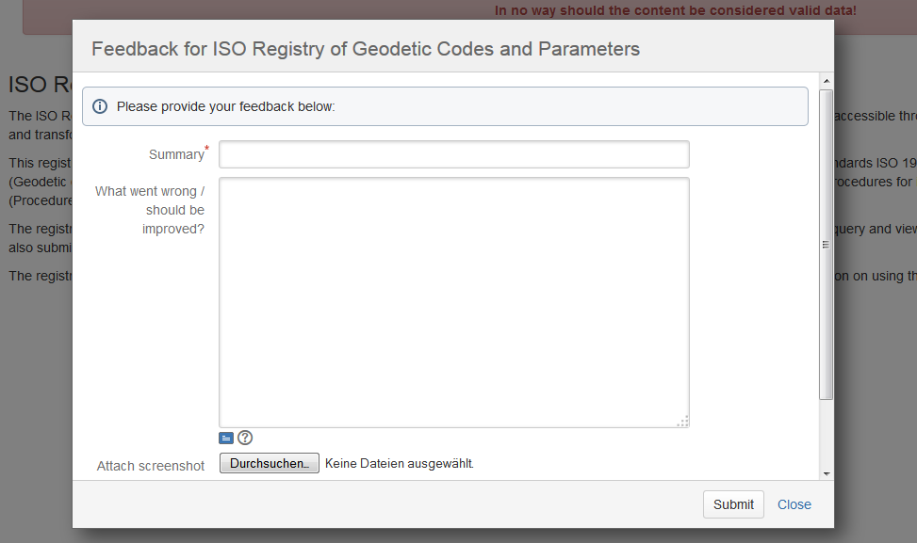

Fig. 5 – Feedback dialog

## Sign up for the registry

In order to be able to submit new content to the ISO Registry of Geodetic Codes and Parameters or propose changes to existing contents, you will need to create a user account and subsequently log in to the registry software.

To start the registration process, first click on *Login* in the upper right corner of the page and then click on the *Register* button.

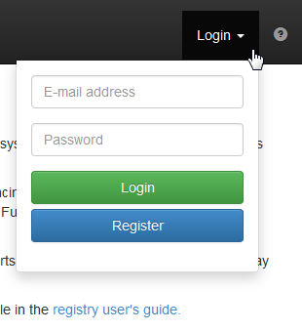

Fig. 6 - The Login dropdown

Now fill out all fields of the user registration dialog and make sure that your e-mail address is spelt correctly. If your organization is not in the list of organizations, check the *My organization is not listed* box. Enter the name of your organization on the following page and press *Save*.

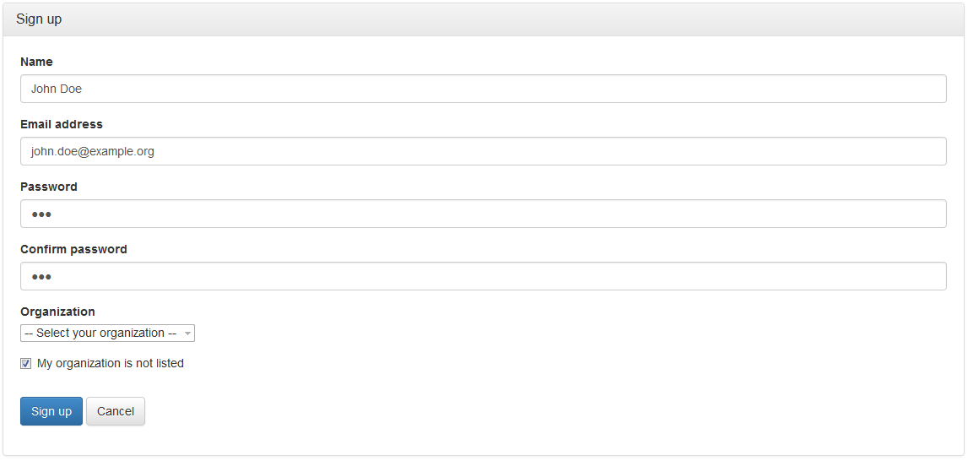

Fig. 7 – The sign-up form

The sign-up form contains the following fields:

|  |  |
| --- | --- |
| Field | Description |
| Name | Your full name |
| E-mail address | A valid e-mail address. All registry-related e-mails will be sent to this account. |
| Password | Your password needed for subsequent logins to the registry website. |
| Confirm password | The same password for confirmation |
| Organization | Select the organization you are affiliated with. The selection of the organization influences which roles you may assume in the registry and in whose name you may make proposals to the registry, so make sure that you select the correct organization. |
| My organization is not listed | In case your organization in not listed, you must check this box and subsequently provide the name of your organization. By creating a new organization you will automatically become that organization’s Point of Contact. |

Tab. 2 - Signup form fields

You will receive an e-mail to confirm your registration. Please follow the instructions in the e-mail and open the contained confirmation link in your web browser.

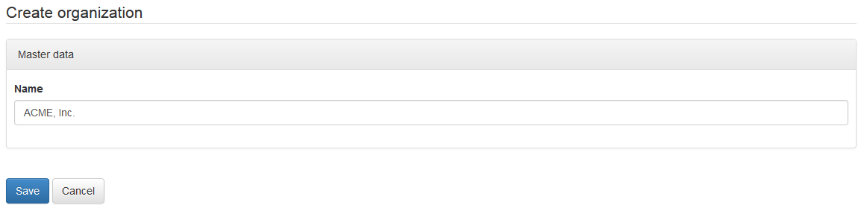

Fig. 8 – Creating a new organization

You may now log in to the registry by clicking on *Login* (top right), entering your e-mail address and password and pressing the *Login* button.

## Manage your account

To modify your personal details, log in to the registry and click on  on the bottom of the application menu on the left hand side.

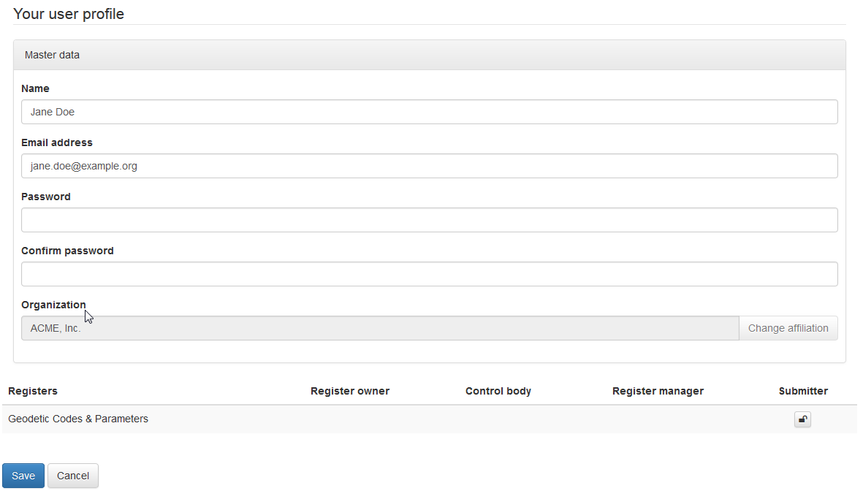

Fig. 9 - My profile screen

If you wish to change your password, enter you new password in the *Password* and *Confirm password* fields before you click *Save*. If you leave both fields empty, your password will remain unchanged.

At the bottom of the user profile page a list of roles with regard to the registers inside the ISO Registry of Geodetic Codes and Parameters is displayed. If a role was delegated to you by your organization, this is indicated by a check marked box. If your organization has a role in the register but that role was not yet delegated to you, you may request delegation of the role by clicking the  button below the role name. When you click the button, the Point of Contact of your organization is informed about your request.

For more details on roles and delegations, please refer also to section 3.3.

# The registry in detail

## Registers

The registry currently consists only of the *Geodetic Codes & Parameters* register.

## Item classes

The *Geodetic Codes & Parameters* register contains the following item class groups and item classes:

|  |  |
| --- | --- |
| Item class group | Contained item classes |
| Coordinate Reference Systems | * Engineering CRS * Geodetic CRS * Projected CRS |
| Coordinate Systems | * Cartesian Coordinate System * Ellipsoidal Coordinate System * Spherical Coordinate System * Vertical Coordinate System |
| Datums | * Engineering Datum * Geodetic Datum * Vertical Datum |
| Coordinate Operations | * Concatenated Operation * Conversion * Transformation |
| Other | * Coordinate System Axis * Ellipsoid * Operation Method * Operation Parameter * Prime Meridian * Unit of Measurement |

Tab. 3 - Item class groups & item classes

## Roles

The ISO Registry of Geodetic Codes and Parameters defines the following roles:

|  |  |
| --- | --- |
| Role | Definition |
| Submitting organization | Organization authorized by a register owner to propose changes to the content of a register [1] |
| Control Body | Group of technical experts that makes decisions regarding the content of a register [1] |
| Register Manager | User/organization to which management of a register has been delegated by the register owner [1] |
| Register Owner | User/organization that establishes a register [1] |
| Point of Contact | The Point of Contact is an organization-related role and gives a user the right to delegate the roles held by his organization to other users of his organization. |
| Administrator | Administrators have the right to manage registers, organizations and registry users. An administrator assigns register roles to organizations. The administrator role is global and not connected to a specific register or organization. |

Tab. 4 - Roles in the registry

Roles are assigned to organizations only but may be delegated to affiliated users by the organization’s Point of Contact user. Users who were delegated a role may subsequently act on the organization’s behalf.

# Submitting proposals

The content of the registry is complemented and updated by the submission of proposals by submitting organizations. There are four types of proposals that may be submitted to a register [1]:

|  |  |
| --- | --- |
| Type | Description |
| Addition | Addition is the insertion into a register of an item that describes a concept not described by an item already in the register. |
| Clarification | Clarifications correct errors in spelling, punctuation, or grammar. A clarification shall not cause any substantive semantic or technical change to a registered item. |
| Retirement | Submitting organizations may submit requests for retirement of registered items that are no longer useful for producing data. Retirement is accomplished by leaving the item in the register, marking it retired, and including the date on which it was retired. |
| Supersession | Modification of a registered item that results in substantive semantic or technical change. A supersession is accomplished by including a new item in the register with a new identifier and the date on which it superseded the original item. The original item remains in the register but includes the date at which it was superseded and a reference to the item that superseded it. |

Tab. 5 - Proposal types

## Prerequisites

To submit new content to or update existing in the ISO Registry of Geodetic Codes and Parameters, the following preconditions must be fulfilled:

1. You have created a user account (in the process you have either joined an existing organization or created a new one) and are logged in,
2. your organization was assigned the *Submitter* role by the registry administrator, and
3. the right to act as a *Submitter* was delegated to you by the Point of Contact of your organization (if you created the organization, you automatically become your organization’s Point of Contact).

If these preconditions are fulfilled, you will see additional action buttons when browsing the registry content.

## Submitting new content

To create an addition proposal, browse to the register content by clicking on the register name or on one of the contained item classes in the application menu and subsequently press on the ** button displayed above the register content.

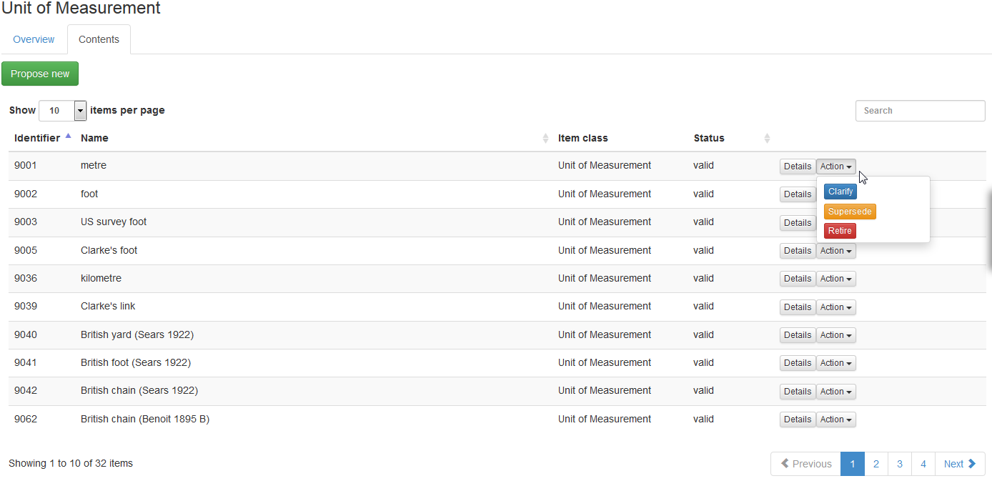

Fig. 10 - Browsing registry content as a submitter

If the list of register item contains only items of a single item class, clicking ** will lead you directly to a proposal form for this item class. Otherwise you must select the item class of your proposal in the following screen.

Mandatory fields of the proposal are marked with the hand-left.png icon. If you omit to fill out a mandatory field, an error message will be displayed and the omitted fields are highlighted in red once you try to save or submit the proposal. Please note that the omitted field need not necessarily be in the current tab or accordion pane. If you are unsure why an error message is displayed, make sure to check all tabs and accordion panes for omitted mandatory fields.

|  |  |
| --- | --- |
| Action | Description |
| Save proposal | The proposal is saved for later submission (cf. 5.1.3) with the status *not yet submitted*. You may edit the proposal or start a discussion (cf. 5.1.1). |
| Submit proposal | The proposal is submitted to the registry to be reviewed by the register manager. |

Tab. 6 - Save proposal vs. submit proposal

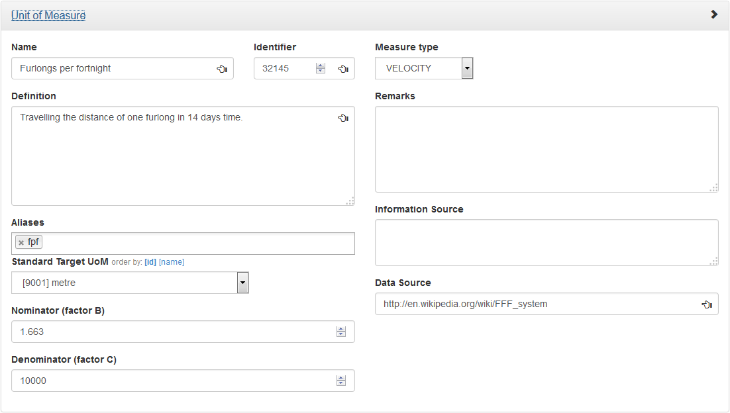

Fig. 11 - Addition of a Unit of Measurement, item details

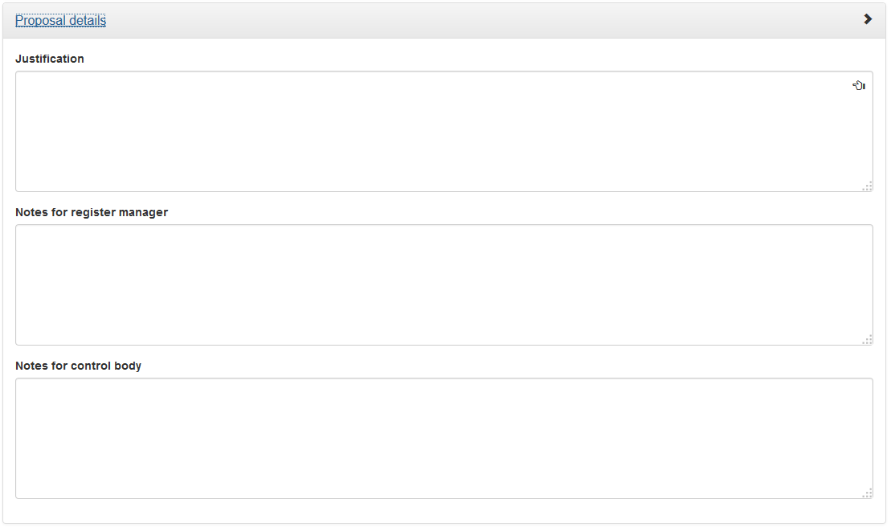

Fig. 12 - Proposal details

In addition to the item details, every proposal requires additional management information. The following attributes in the Proposal details section are part of every proposal [1]:

|  |  |
| --- | --- |
| Attribute | Description |
| Justification | Explain why the proposed change should be implemented in the registry. Providing a justification is mandatory for every proposal. |
| Register manager notes | Here you may add notes relevant for the register manager’s handling of the proposal. Individual entries within the notes should be dated. |
| Control body notes | Here you may add notes relevant for the control body’s decision concerning the proposal. Individual entries within the notes should be dated. |

Tab. 7 - Proposal details

In case there are mandatory attributes not filled out when you click Save proposal or Submit proposal, the following message will appear at the bottom of the screen:



Fig. 13 - Error message on omitted mandatory field

## Clarifying an item

To clarify an item, press  in the *Action* dropdown of the item to be clarified. You will be presented with a screen similar to the one described in the previous exception. All attributes will be filled with data from the item to be clarified and you can edit the attributes that require clarification. You cannot, however, edit the identifier of an item or change links to other register item, as this does not qualify as a non-semantic change. If you wish you change these attributes, you will have to perform a *Supersession* instead.

## Superseding an item

To supersede an item, press  in the *Action* dropdown of the item to be superseded. This will open a screen where you can add a new item (or multiple) new items that are to supersede the original item:

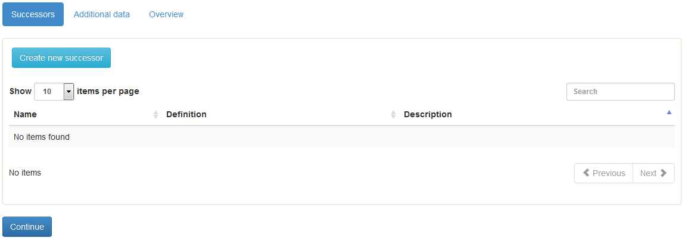

Fig. 14 - Adding successor items in a supersession

When you finished adding successors, click *Continue* to proceed to the next screen. In the *Additional data* tab you will have to provide proposal details as described in Tab. 7.

## Retiring an item

To retire an item, press  in the *Action* dropdown of the item to be retired. This will open a popup where you will have to provide proposal details as described in Tab. 7.

# Managing proposals

## Tasks as a submitter

If you are a *Submitter* for your organization you will have access to the submitting organization overview page by clicking on *Submitting organization* in the *Management* folder of the application menu:



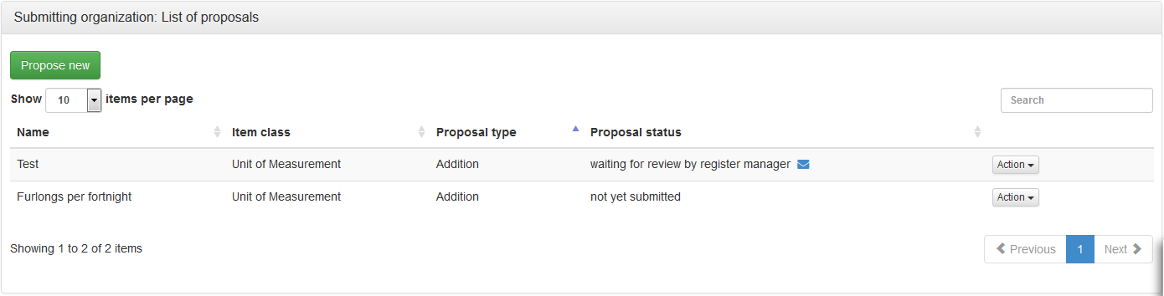

Fig. 15 - Submitting organization overview

### Discussing a proposal

**Starting a discussion**

For proposals having the status *not yet submitted* you may start a discussion by clicking  in the action menu next to the proposal. This will lead to a screen allowing you to invite participants to the discussion.

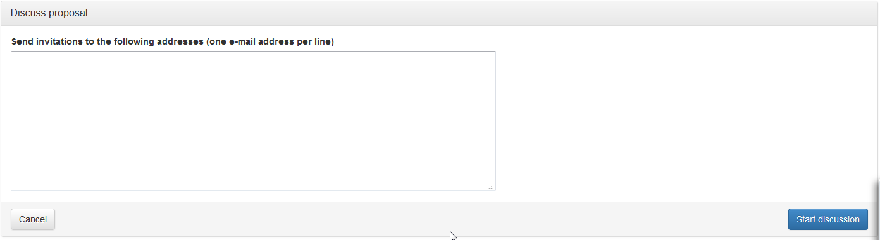

Fig. 16 - Starting a proposal discussion

To invite participants, enter their e-mail addresses in the text field. When you are finished, click *Start discussion*. The registry will then send e-mails to the addresses containing a link to the discussion, allowing the recipients to take part in the discussion.

**Starting a thread**

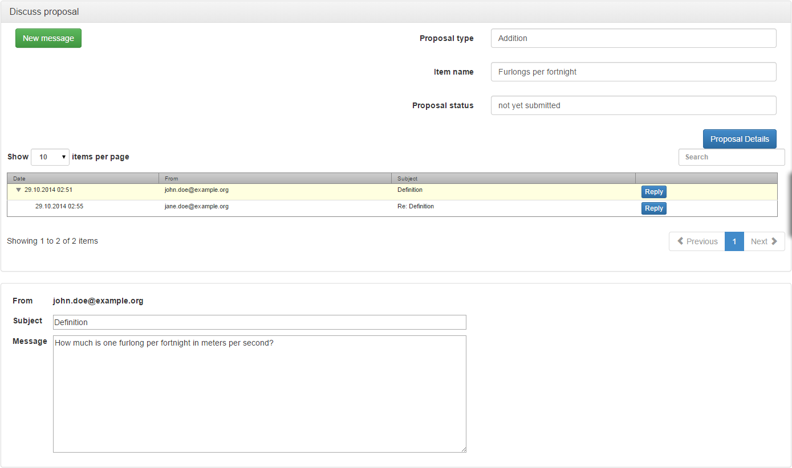

Fig. 17 - Proposal discussion forum

The proposal discussion forum gives an overview of existing threads. To view a message, click on it. The message content will be displayed in the bottom section of the screen.

If there are replies to a message, a small triangle is displayed on the left side of the message entry. You can click the triangle to open the message thread.

You may start new threads by clicking  or reply to a message by clicking .

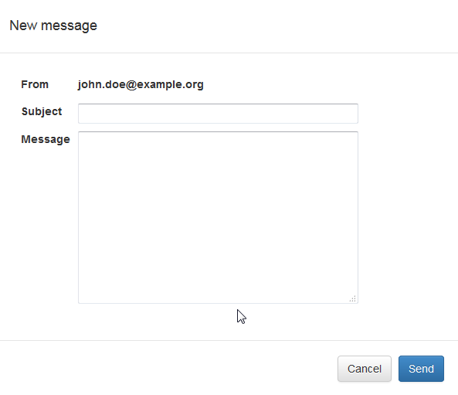

Fig. 18 - Creating a forum message

### Withdrawing a proposal

You may withdraw a proposal at any time by pressing the *Withdraw* button for the respective proposal on the submitting organization overview page.

### Submitting saved proposals

To submit a saved proposal with the status *not yet submitted*, click on the *Submit proposal* button in the action dropdown.

### Appealing the control body decision

A submitting organization may appeal the rejection of the proposal by the control body to the register owner by clicking *Appeal to owner* on the rejected proposal. Appealable proposals have the status *rejected/appealable*.

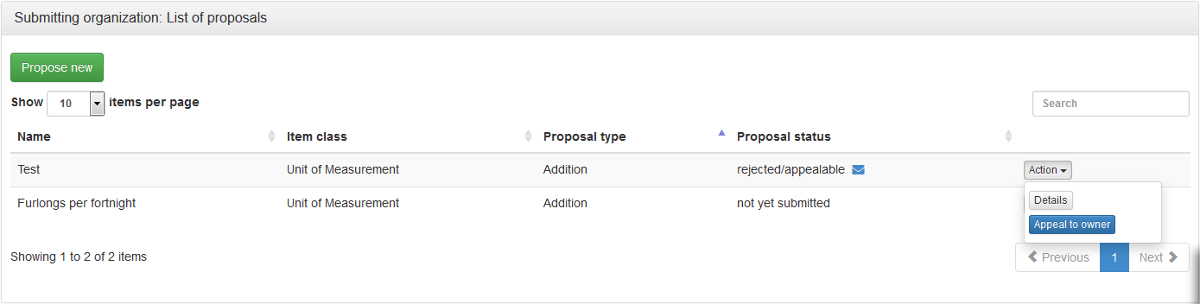

Fig. 19 - Appealing a rejected proposal

When you appeal a rejected proposal, it is required that you provide additional information that may be used by the register owner to decide the appeal in the following screen.

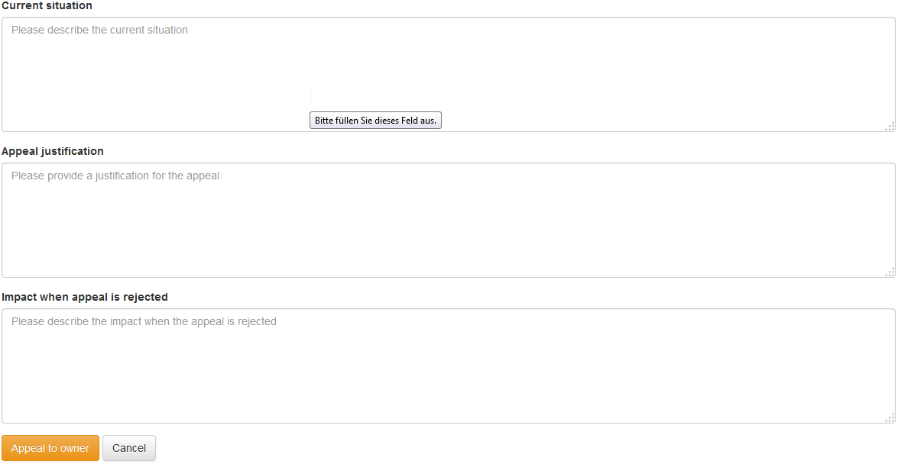

Fig. 20 - Providing appeal details

|  |  |
| --- | --- |
| Attribute | Description |
| Current situation | Describe the current situation (status quo), i. e. the situation before the rejected proposal was created. |
| Appeal justification | Provide a justification why you think that the control body’s decision should be overruled. |
| Impact when appeal is rejected | Describe the impact when the control body’s decision is not overruled. |

Tab. 8 - Appeal information

## Tasks as a register manager

After a new proposal has been submitted, it is the register manager’s responsibility to review the proposal for completeness. The register manager returns the proposal to the submitter if the proposal is incomplete or he deems the submitting organization not qualified to make the proposal in question.

To view a list of proposals that are waiting for review, click on *Register manager* under the *Management* folder in the application menu.

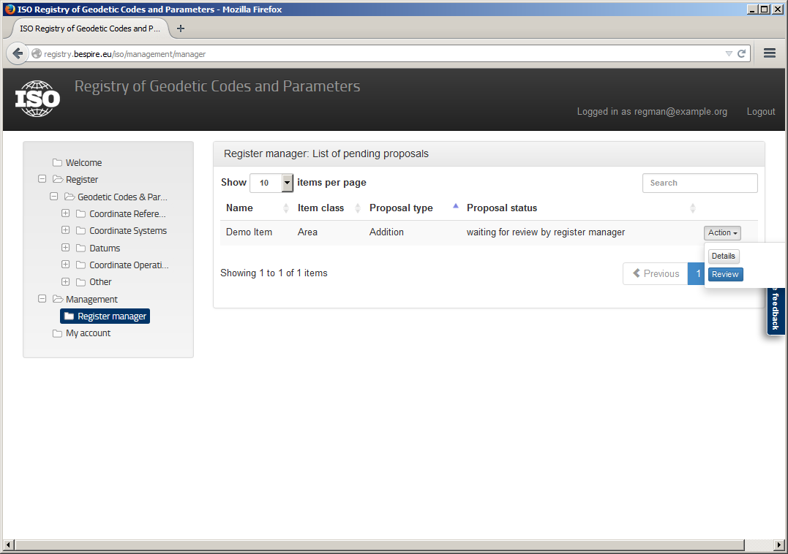

Fig. 21 - Register manager overview

To perform a review of a proposal, press the *Review* button. You may then accept the proposal and hand it over to the control body for decision or return the proposal to the submitter for revision.

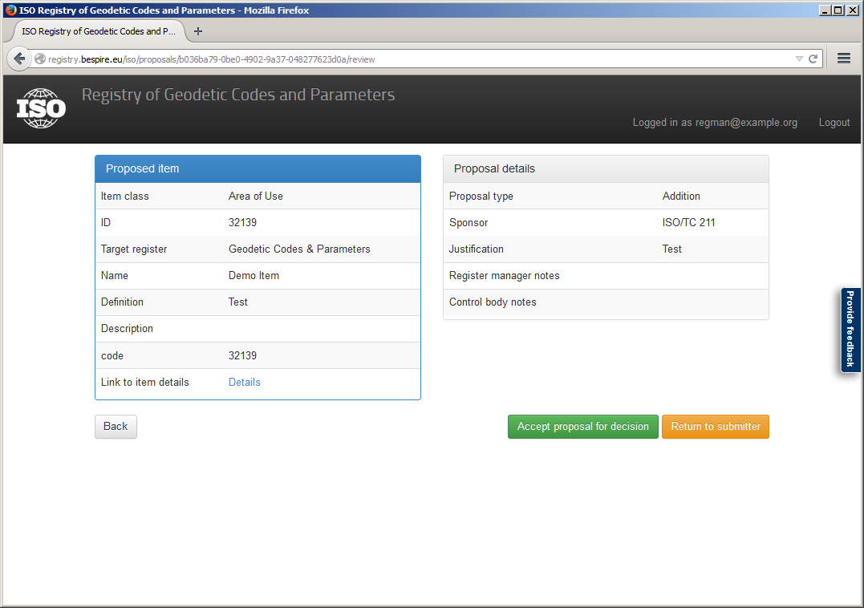

Fig. 22 - Reviewing a proposal as register manager

## Tasks as a control body member

If a proposal was accepted for decision by the register manager, the control body of the register must perform a thorough review of the proposal content. The control body then decides whether to accept the proposed register item into the register, to reject the proposal or to return the proposal to the submitter for revision.

If you were delegated the *Control Body* role by your organization you may review all proposals that are waiting for a decision by visiting the control body overview page (management area).



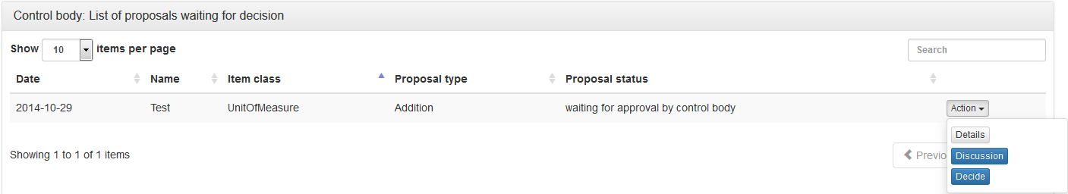

Fig. 23 – Control Body overview

## Discussing a proposal

Although the registry software allows any user having the *Control Body* role to decide a proposal, it may be required to involve all members of the control body in the decision. Therefore, the registry software includes a discussion forum where the proposal decision may be discussed. Refer to section 5.1.1 for a detailed description of the discussion forum. As part of the discussion, the control body should decide, which member will execute the proposal decision once it is made.

## Deciding a proposal

To decide a proposal, one member of the control body must execute the control body’s decision within the registry software. To do so, open the *Action* dropdown of the proposal in question and click on  to open the control body review page.

The following decisions are available:

|  |  |
| --- | --- |
| Action | Description |
| Accept proposal | The proposal is accepted. You will be prompted to provide information, where and when the decision to accept the proposal was made by the control body. You should add the date and venue of the control body meeting in the course of which the proposal was decided upon. |
| Return to submitter | The proposal will be returned to the submitter and receive the status *not yet submitted*. You will be prompted to add a note to the submitter indicating why the proposal is returned. |
| Reject proposal | The proposal is rejected. You will be prompted to provide information, where and when the decision to reject the proposal was made by the control body. The submitting organization may appeal to the register owner in this case. |

Tab. 9 - Available proposal decisions

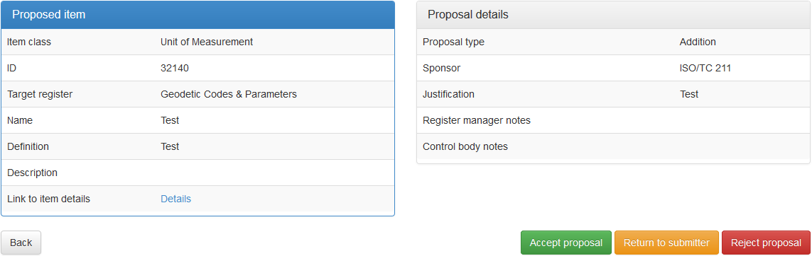

Fig. 24 - Reviewing a proposal as control body

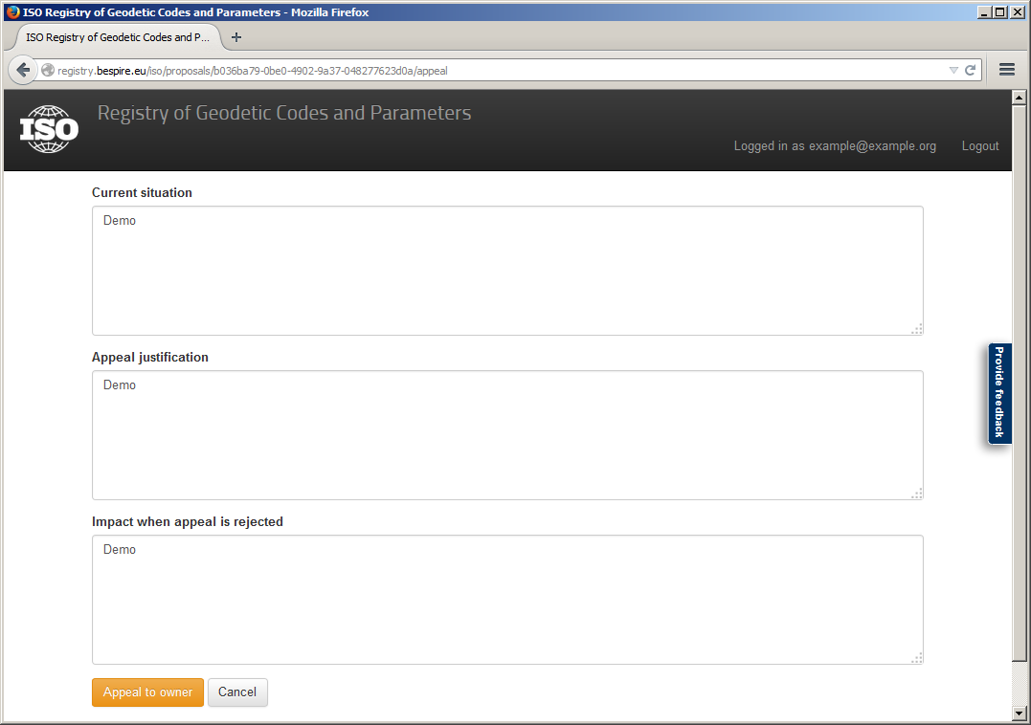

Fig. 25 - Preparing an appeal

# Managing your organization

## Tasks as an organization’s Point of Contact

Users having the role *Point of Contact* have the right to delegate all roles assigned to their organization to users affiliated with the organization. Additionally, a Point of Contact is responsible for confirming the membership of new users and for delegating the *Point of Contact* role to other users of the organization.

If you are the Point of Contact for your organization, you will have access to the Point of Contact overview page. The link to the overview page can be found in the *Management* folder of the application menu.

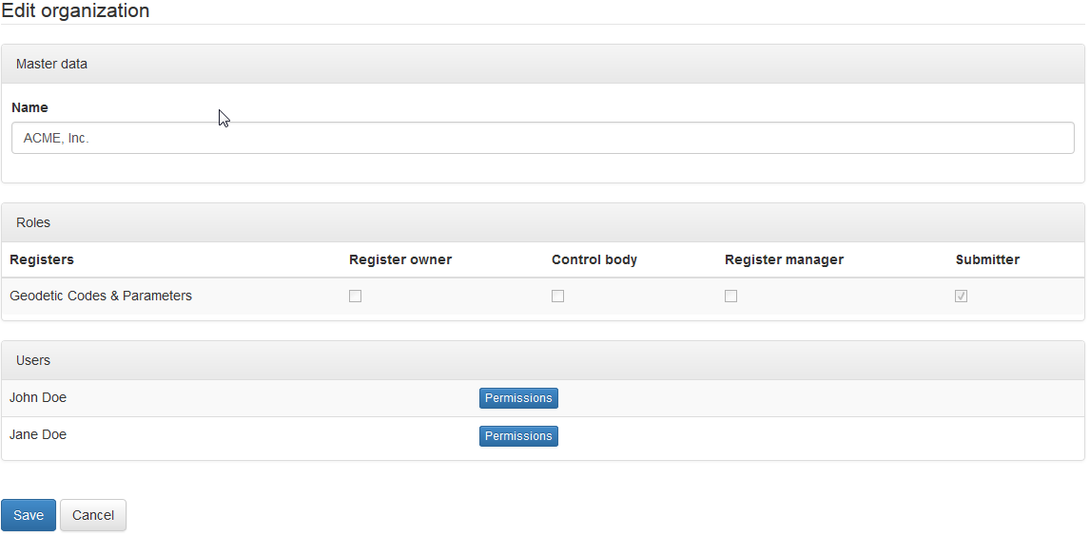

Fig. 26 - Point of Contact overview

## Delegating rights to organization user

To delegate a role to a user of your organization, click  next to the user’s name. This will open a popup displaying the roles available for delegation.

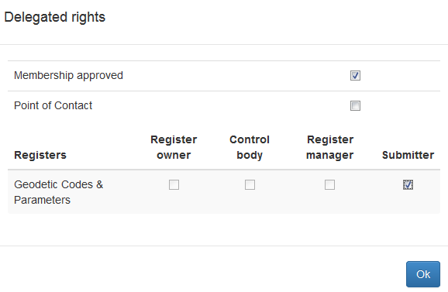

Fig. 27 - Delegating roles to users

Check the appropriate roles and press *Ok*. Your changes in the popup will not be saved until you click *Save* in the main dialog.

## Managing role requests

Users of your organization may request the delegation of roles, as described in section 2.7. If a user has requested the delegation of one or more roles, the number of requested roles will appear next to the user’s name like this:



When you open the permissions popup for that user, the requested roles will be highlighted.

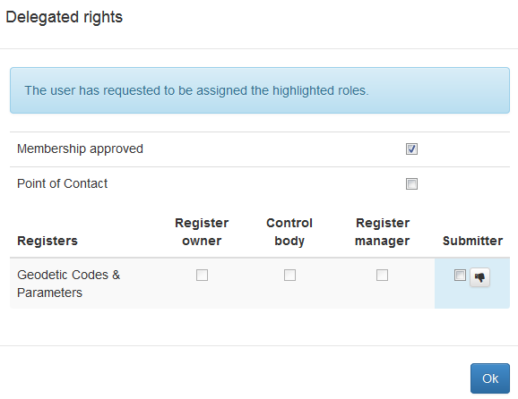

Fig. 28 - Managing role requests

You can accept the request by checking the respective check box, closing the popup by clicking *Ok*, and saving the main dialog by clicking *Save*.

In case you wish to deny the request, press the  button. Note that denying a role request will be saved immediately. The requesting user may, however, again request the delegation of the same role at a later time.

# Bibliography

|  |  |
| --- | --- |
| [1] | ISO, *ISO 19135 - Procedures for item registration,* 2005. |

# List of figures

Fig. 1 – Item classes within an item class group 2

Fig. 2 - List of registered items 3

Fig. 3 - Details of a registered item 4

Fig. 4 - Management information of a register item 5

Fig. 5 – Feedback dialog 6

Fig. 6 - The Login dropdown 6

Fig. 7 – The sign-up form 7

Fig. 8 – Creating a new organization 8

Fig. 9 - My profile screen 8

Fig. 10 - Browsing registry content as a submitter 13

Fig. 11 - Addition of a Unit of Measurement, item details 14

Fig. 12 - Proposal details 14

Fig. 13 - Error message on omitted mandatory field 15

Fig. 14 - Adding successor items in a supersession 16

Fig. 15 - Submitting organization overview 17

Fig. 16 - Starting a proposal discussion 17

Fig. 17 - Proposal discussion forum 18

Fig. 18 - Creating a forum message 18

Fig. 19 - Appealing a rejected proposal 19

Fig. 20 - Providing appeal details 19

Fig. 21 - Register manager overview 20

Fig. 22 - Reviewing a proposal as register manager 21

Fig. 23 – Control Body overview 21

Fig. 24 - Reviewing a proposal as control body 22

Fig. 25 - Preparing an appeal 23

Fig. 26 - Point of Contact overview 24

Fig. 27 - Delegating roles to users 24

Fig. 28 - Managing role requests 25

# List of tables

Tab. 1 - Proposal management information 5

Tab. 2 - Signup form fields 7

Tab. 3 - Item class groups & item classes 10

Tab. 4 - Roles in the registry 11

Tab. 5 - Proposal types 12

Tab. 6 - Save proposal vs. submit proposal 13

Tab. 7 - Proposal details 15

Tab. 8 - Appeal information 20

Tab. 9 - Available proposal decisions 22